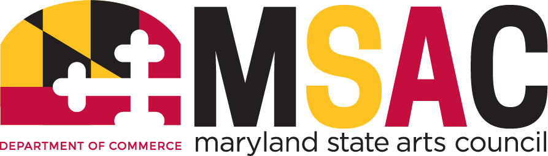
MSAC Executive &
Program Planning & Evaluation Committee

MEETING MINUTES
April 27, 2021

The Executive Committee shall have general supervision of the affairs of the Council, make recommendations to the Council, and shall perform other duties as specified…

It shall be the duty of the Program Planning & Evaluation committee to review and assess, as necessary, on-going programs maintained by the Council; to study new program initiatives for Council consideration; to direct the Council’s on-going planning process with respect to policies, programs, and Council operations; to make recommendations for Council action on these matters when appropriate; and to undertake such other duties as the Council may from time to time direct. The committee shall consist of no fewer than three members.

Chair Julie Madden called the meeting to order at 11:02 a.m. Julie went over the guiding documents which included Maryland State Arts Council’s (MSAC) equity and justice statement, vision, mission, and strategic planning goals.

Assistant Secretary Tom Riford explained to the committee the differences in which an Executive Director is evaluated by a non-profit organization opposed to a board operating under state government. Under the latter employees face evaluations that follow a tiered process of multiple goal setting reviews which are semi and annual. There are also customer service surveys that are a part of the evaluation as the governor's customer service initiative through the Department of Budget and Management (DBM).

He went on to explain the makeup of the board which consists of seventeen Councilors, thirteen of whom are appointed by the Governor, two of whom are appointed from the members of the General Assembly, one by the President of the Senate and one by the Speaker of of the House of Delegates, and two of whom are appointed from the at-large citizens in Maryland, one by the President of the Senate and one by the Speaker of the House of Delegates, as provided in the Act. Tom mentioned that board member interaction is more aligned with the staff who have set a standard for goal setting and how those goals are met.

The Assistant Secretary reviews employee evaluations and recommendations are submitted to the Secretary of Commerce and then sent to DBM. He expressed again his appreciation for the board. Council members expressed gratitude for Tom’s candor in regards to the inner workings of employee evaluations and personnel confidentiality for an art council operating under state government.

Executive Director (ED), Ken Skrzesz, introduced the Independent Artist Network (IAN), an artist employment initiative with the intention to create a plan that encourages sustainability as a thriving economic force. It will be a point of focus for future investment. MSAC staff has identified a glaring need within programs for an employment network for independent artists (artists not affiliated with an established company or organization).

The ED presented several factors that have converged to lay the foundation for a new approach to programming for independent artists to encourage multi-faceted, long range employment such as: Increased connection between MSAC and independent artists statewide; MSAC’s new website; FY22 budget increase; and the global pandemic has caused artists to rethink their living and working arrangements.

He went on to share that the IAN will act as an umbrella under which all MSAC programs available to support employment for independent artists will be housed. The IAN, via the Maryland Arts Directory, will replace current rosters and other arts discipline-specific lists. The IAN will be a “one stop” platform to be used by potential employers. Programs with recommended FY22 budget allocations include: Arts in Education Grant, $550,000; Creativity Grant, $400,000; Public Art Across Maryland Grant, $450,000; and Touring Grant, $200,000 for a total commitment of 1.6M to the IAN program.

The ED informed the committee of the staff’s next steps which include: collaborating with other agencies and organizations; defining a panel review schedule that supports the common application process as well as but not limited to creating a common application for all programs that fund employment for independent artists; enhancing procedures for reviewing artists in the field and enhancing overall communication.

Committee members were very excited about the new initiative. Councilors agreed the new initiative would have a profound impact on independent artists and the arts in Maryland. Questions were raised in regards to other states implementing anything similar. Program Director Dana Parsons informed the committee that other states do have dedicated program directors for such programming, but none have dedicated this level of financial commitment or marketing efforts. Discussion held about collaborating with Arts & Entertainment Districts as well as County Arts Agencies. The ED informed the committee that they were the first to be introduced to the initiative for feedback and have yet to reach out to those organizations. The ED will share a briefing memorandum sent to Secretary Schulz about the IAN with committee members. The idea of training young merging independent artists to collaborate with more established artists was also mentioned by councilors. Staff mentioned that the concept also came up in GFO listening sessions and has been noted for further consideration.

Dana Parsons provided a grants update and informed the committee that listening sessions have been scheduled for the new Tiered Funding Model. Monday, April 26: Small Orgs; Wednesday, April 28: Mid-Size Orgs; and Thursday, April 29: Large Orgs, 2-3 p.m. Public call for editors to follow listening sessions.

Emergency Grant Round 4 is well underway and $5M has been recommended across 539 applications. 147 applications were not recommended for funding. $535,818 to Arts Organizations across 34 grants in 10 counties, who have not received previous MSAC funding, in alignment with the legislation for this funding. $1,977.000 to Independent Artists across 659 grants in 23 counties. $2,487,187 to Arts Organizations, County Arts Agencies, and Arts & Entertainment Districts across 146 grants in 20 counties. MSAC has hired a contractor to assist with processing, notifications will be sent out by May 1 after which payments will occur. The usual amount of grant applications received is 800 and there were 1000 additional emergency grants reviewed by program directors. The grants department thanked their team and acknowledged Fiscal Officer, Shaunte Roper for her guidance.

Deputy Director Steve Skerritt-Davis provided a staffing update and informed the council that a candidate had been chosen for the Program Director County Arts Councils and Arts & Entertainment Districts position. The fabulous candidate is in the home stretch with Human Resources. The Marketing, Traditions and Grants Intern positions are currently vacant.

The Program Planning and Evaluation (PPE) committee discussed the name of the committee being changed for alignment with the committee’s purpose. Council Liaison Keyonna Penick presented Article VII - Committees from the MSAC by-laws which provided the definition of the PPE Committee and Article XII Amendment of the By-Laws (see MSAC By-Laws). PPE Committee Chair Joan Lyon shared that after her research in the MSAC meeting archives she found that the name may have been inadvertently changed by a typo.

Shelley Morhaim made a motion to change the name Program Planning and Evaluation to Program Policy and Evaluation and move the change to the full Council for Attorney General’s approval. Benny Russell seconded the motion. All in favor. None opposed.

Advocacy Update, Nicholas Cohen unable to attend. Keyonna will reach out to Nicholas for an update and report back to the council.

Jack Rasmussen mentioned that the Independent Artist show installed in Baltimore Washington International Airport is really great and thanked Rosa Chang especially for her hard work. The show will eventually be virtual.

Adjournment 11:54 a.m.

